Fleetrock Alvys Business Central Integration

This document provides details on how to setup and use the integration.

Setup:

Fleetrock:
To use the integration, a user must be created in Fleetrock with the Customer :
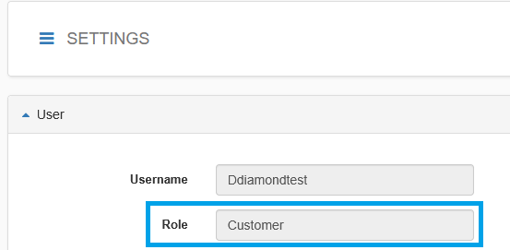
The user must also have an API key created with “Use JSON Web Tokens(JWT)” disabled:
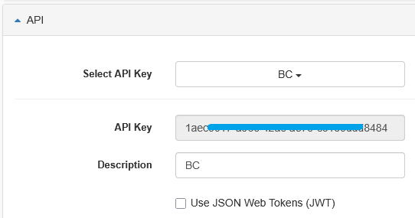
Under the Profile settings for the user, make a note of the Time Zone selected, as it will be needed later:
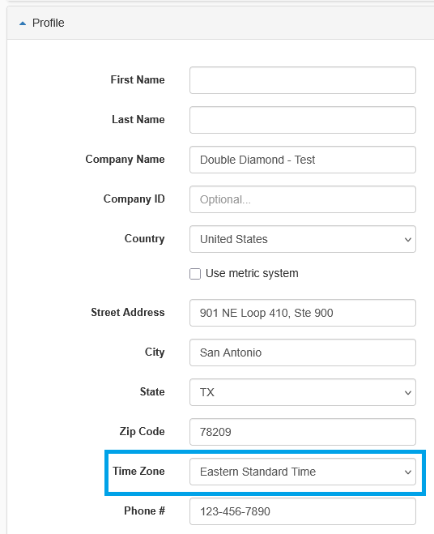

Open the Fleetrock Setup in Business Central, via the Search function. This is where are Fleetrock related settings are configured:
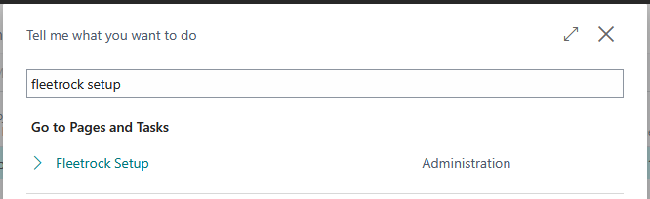
Open the Integration tab of the Fleetrock Setup page:
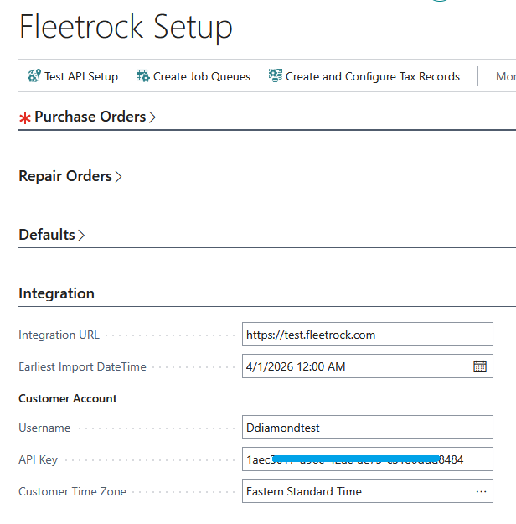
Enter one of the following in the Integration URL:
- https://test.fleetrock.com - Fleetrock Test environment
- https://www.fleetrock.com - Fleetrock Production environment
Enter the Username, API Key and Timezone of the Fleetrock user previously configured.
If you want the integration to ignore documents from before a certain date, enter a value in the Earliest Import DateTime field.

Once all the fields in the Integration tab are filled in, select the “Test API Setup” button at the top of the page. If the setup is correct, it should show a message similar to below:
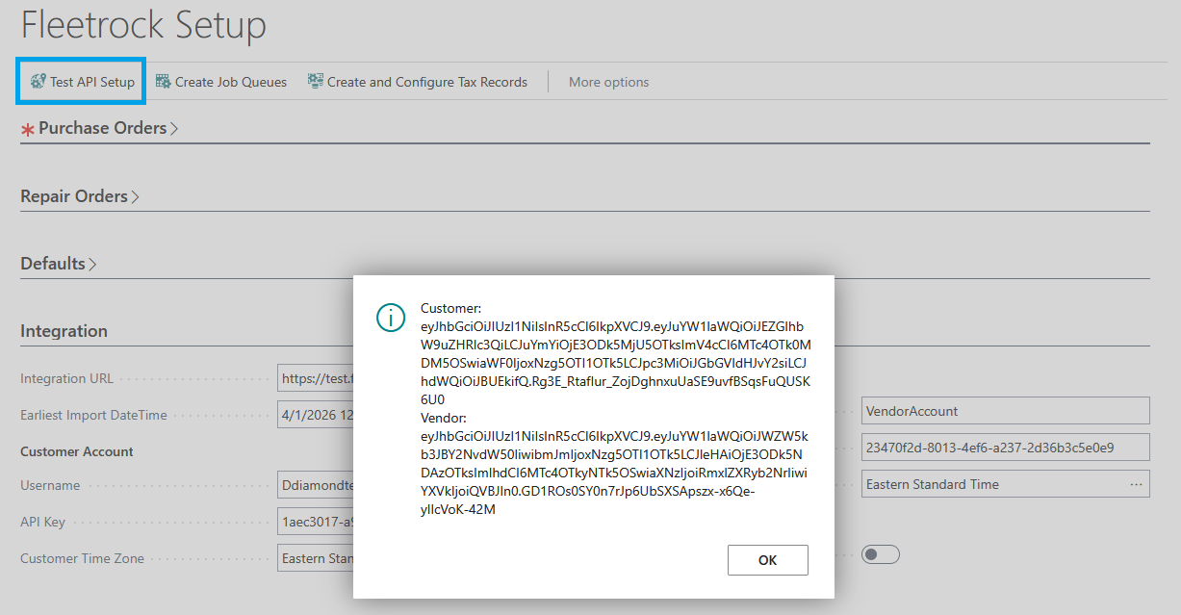
If the setup has issues, it will display the errors for the Customer and Vendor accounts:
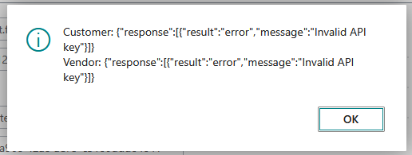

Open the Defaults tab, and select the “Create and Configure Tax Records” button:

This will automatically create a Tax Area record and Tax Jurisdiction record both with code FLEETROCK if they are not already in the system, and assign them to the related fields: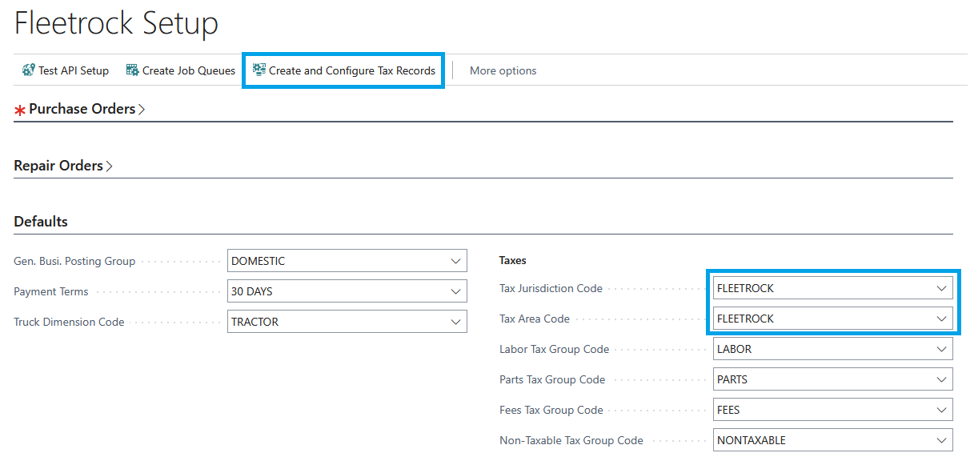
Populate the other setup fields.
For the Truck Dimension Code, this will cause any Asset in Fleetrock to be imported as a Dimension Value for the Dimension assigned to the field, and set on any imported documents from Fleetrock. If the field is left blank, documents will still be imported but the asset will not be assigned to the document in Business Central as a Dimension

Open the Repair Orders tab
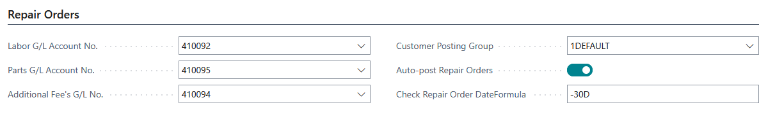
Fill in the GL Account No. fields, and the Customer Posting Group field. These fields will be used when creating Sales Invoices from imported Repair Orders.
Auto-Post Repair Orders specifies if Sales Invoices should be automatically Posted when imported from Repair Orders.
Check Repair Order DateFormula specifies how far in the past to check for any Repair Orders that should have been imported but were missing initially.
Select the “Create Job Queues” button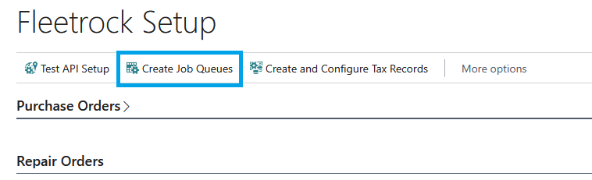
This will create background job queues to automatically import Repair Orders into Business Central:
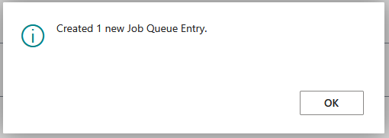
If the job queues are already created, it will not create additional job queues.

Processing
When a Repair Order is invoiced, it will automatically be imported as a Sales Invoice in Business Central via the Job Queue. If the Auto-Post Repair Orders field on the Fleetrock Setup page is set to true, the Sales Invoice will also be posted after being imported.
All imported Sales Invoice will have the document number of the related Fleetrock Repair Order:
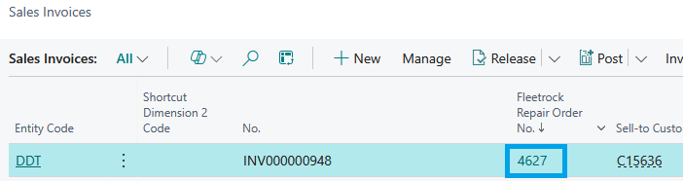

Alvys

Open the Alvys Sales Setup page:

Populate the Integration URL with the following: https://integrations.alvys.com/api/p/v1.0/
Populate the Client ID and Client Secret from the settings in Alvys:
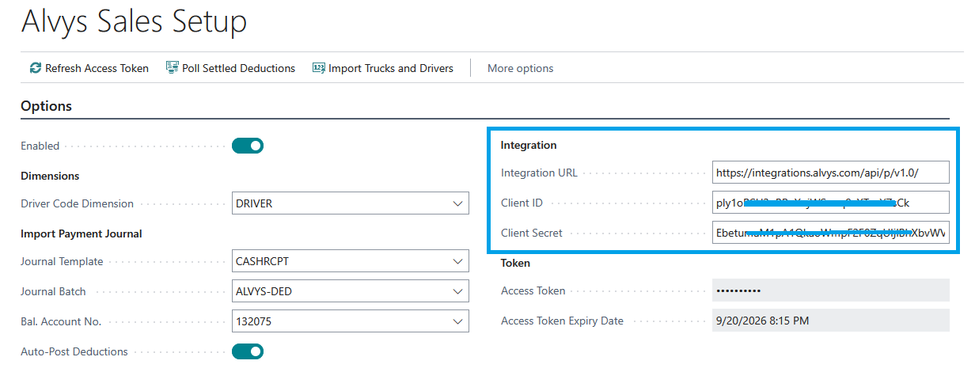
Select the “Refresh Access Token” button to confirm the connection is working, if it is the Access Token Expiry Date will automatically update to be 1 hour in the future from the current time:
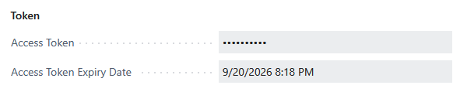
If the connection is not valid, an error will be displayed with details of the issue:
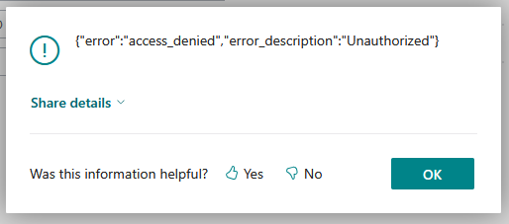
Populate the Driver Dimension with the proper Dimension value, if using Dimensions for Drivers.
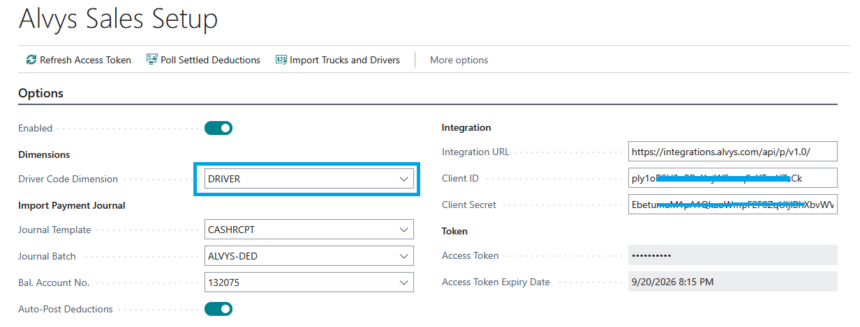
Populate the Journal Template and Journal Batch fields. These will determine where payments to deductions in Alvys will be imported into Business Central:
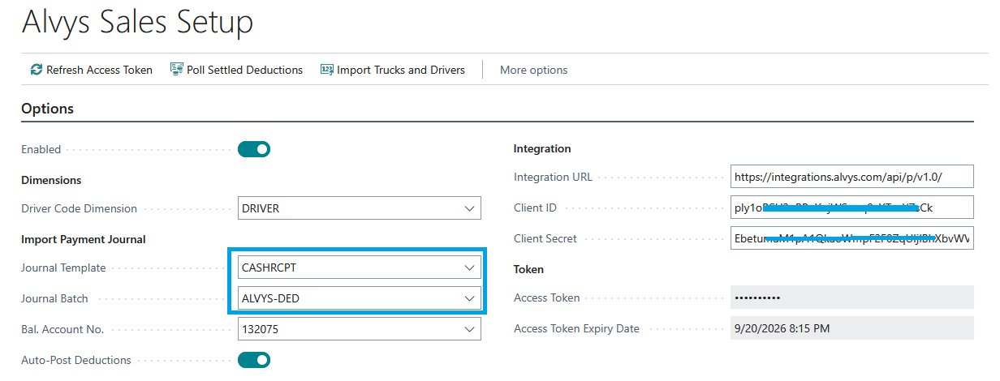
Populate the Bal. Account No., this will determine which G/L Account Alvys deduction payments are posted against:
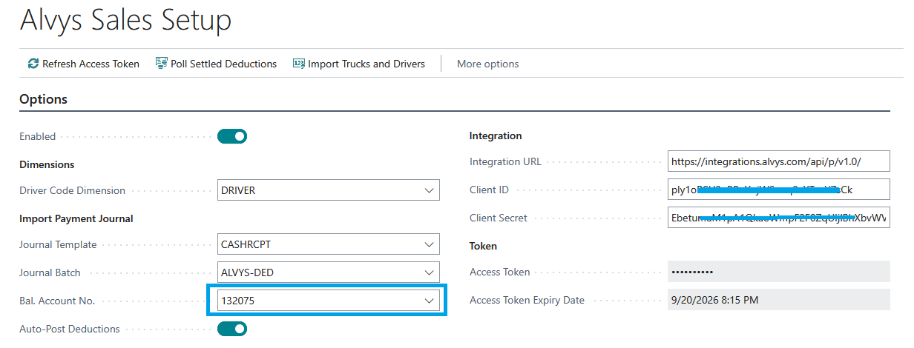
Set Auto-Post Deductions to try if journal lines created from Alvys Deduction payments should be automatically posted after importing.
Once all settings have configured, set the Enabled field to true. Changing this field to false at anytime will disable the integration and prevent any further imports or postings while it’s set to false.

Processing
The Alvys Integration works by automatically creating a Deduction in Alvys whenever a Sales Invoice is posted

